Black, Lavoisier, and Rumford on Heat

1. Joseph Black (1728-1799), Lectures on the Elements of Chemistry
[Specific Heat] It was formerly supposed that quantities of heat required to increase the heat of different bodies by the same number of degrees were directly proportional to the quantity of matter in each; and therefore, when the bodies were of equal size, the quantities of heat were in proportion to their density. But very soon after I began to think on this subject (anno 1760), I perceived that this opinion was a mistake, and that the quantities of heat which different kinds of matter must receive to reduce them to an equilibrium with one another, or to raise their temperature by an equal number of degrees, are not proportional to the quantity of matter in each, but in proportions widely different from this, and for which no general principle or reason can yet be assigned…
…Let us suppose some water to be at the 100th degree of heat, and that an equal measure of warm quicksilver at the 150th degree be suddenly mixed and agitated with it. We know that mixing the cold water at 100° with an equal measure of warm water at 150° would produce water at 125°; the heat of the warm water being lowered by 25°, while that of the cold raised that much. But when warm quicksilver is used in place of warm water, the temperature of the mixture turns out 120° only instead of 125°. The quicksilver, therefore, is become less warm by 30°, while the water has become warmer by 20° only; and yet the quantity of heat which the water has gained is the very same quantity which the quicksilver has lost. Thus the same quantity of the matter of heat has more effect in heating quicksilver than in heating an equal measure of water, and therefore a smaller quantity of it is sufficient for increasing the sensible heat of quicksilver by the same number of degrees. The same thing appears, whatever way we vary the experiment. …. [Thus] quicksilver, notwithstanding its great density and weight, requires less heat to heat it, than that which is necessary to heat, by the same number of degrees, an equal measure of equally cold water. Quicksilver, therefore, may be said to have less capacity for the matter of heat. …This capacity of different bodies for heat we can learn only by making experiments….
[Suppose] we had a thousand masses of matter, of the same size and form, but of different materials, and placed them all in the same room, until they assumed the same temperature. Suppose we then introduced into that room a great mass of red hot iron, whose heat raised the temperature of all of the bodies by 20°. The heat thus communicated from the iron would not be equally divided or distributed among the bodies. Some would attract and retain a much greater quantity of this heat, or matter of heat, than others… Perhaps not any two of them would receive precisely the same quantity. Each, according to its particular capacity, or its particular force of attraction for this matter, would attract and require its own peculiar quantity to raise its temperature by the 20 degrees…
[Latent Heat] Fluidity was universally considered as produced by a small addition to the quantity of heat which a body contains, when it is once heated up to its melting point; and the return of such a body to a solid state, as depending on a very small diminution of the quantity of heat, after it is cooled to the same degree… This was the universal opinion on this subject, so far as I know, when I began to read my lectures in the University of Glasgow, in the year 1757. But I soon found reason to object to it, as inconsistent with many remarkable facts, when attentively considered….
…If we attend to the manner in which ice and snow melt, when exposed to the air of a warm room, or when a thaw succeeds to frost, we can easily perceive, that however cold they might be at the first, they are soon heated up to their melting point, or begin soon at their surface to be changed into water. And if the common opinion had been well founded (if the complete change of them into water required only the further addition of a very small quantity of heat), the mass, though of considerable size, ought all to be melted in a very few minutes or seconds more, the heat continuing incessantly to be communicated from the air around. Were this really the case, the consequences would be dreadful; for, even as things are at present, the melting of great quantities of snow and ice occasions violent torrents and great inundations in cold countries… But, were ice and snow to melt as suddenly as they would if the former opinion were true, the torrents and inundations would be incomparably more irresistible and dreadful. They would tear up and sweep away everything so suddenly that mankind should have great difficulty to escape from their ravages. This sudden liquefaction does not actually happen; the masses of ice or snow melt slowly, especially if they be of a large size… After they begin to melt, they often require many weeks of warm weather before they are totally dissolved into water…. This remarkable slowness with which ice and snow melt struck me as quite inconsistent with common opinion…
...A thermometer, applied to the drops of water [coming] from melting ice will point to the same degree as when it is applied to the ice itself, or if there is a difference, it is too small to deserve notice. A great quantity, therefore, of the heat, or of the matter of heat, which enters into the melting ice, produces no other effect but to give it fluidity, without augmenting its sensible heat; it appears to be absorbed and concealed within the water, so as not to be discoverable by the application of a thermometer.
[Black conducted many experiments with freezing water and thawing ice. They confirmed his expectations: phase transformations require a great deal of heat, which cannot be measured on a thermometer. He then conducted experiments with boiling water and condensing steam…]
And, as the ostensible effect of the heat, in [the former set of experiments], consists not in warming the surrounding bodies, but in rendering the ice fluid, so, too, in the case of boiling, the heat absorbed does not warm surrounding bodies, but converts the water into vapor. In both cases, considered as the cause of warmth, we do not perceive its presence: it is concealed, or latent, and I give it the name of LATENT HEAT.

2. Antoine Lavoisier (1743-1794), Elements of Chemistry
Ch. I: Of the Combinations of Caloric, and the Formation of Elastic Aëriform Fluids
…The particles of all bodies may be considered as subjected to the action of two opposite powers, the one repulsive, the other attractive, between which they remain in equilibrium. So long as the attractive force remains stronger, the body must continue in a state of solidity, but if, on the contrary, heat has so far removed these particles from each other as to place them beyond the sphere of attraction, they lose the adhesion they before had with each other, and the body ceases to be solid.
Water gives us a regular and constant example of these facts. Below Zero of the French thermometer, or 32° of the Fahrenheit, it remains solid, and is called ice. Above that degree of temperature, its particles being no longer held together by reciprocal attraction: it becomes liquid. When we raise its temperature above 80° (212°), its particles give way to the repulsion caused by the heat, and the water is changed into an aëriform fluid.
The same may be affirmed of all bodies in nature: they are either solid or liquid, or in the state of elastic aëriform vapor, according to the proportion between the attractive force inherent in their particles, and the repulsive power of the heat acting upon these…
It is difficult to comprehend these phenomena without admitting them as the effects of a real and material substance, or very subtle fluid, which, insinuating itself between the particles of bodies, separates them from each other. Even if the existence of this fluid is hypothetical, we shall see that it explains the phenomena of nature in a very satisfactory manner.
This substance, whatever it is, being the cause of heat, or, in other words, the sensation which we call warmth being caused by the accumulation of this substance, we cannot, in strict language, distinguish it by the term heat.The same name would then very improperly express both cause and effect… Thus, we have distinguished the cause of heat, or that exquisitely elastic fluid which produces it, by the term of caloric. … We are not obliged to suppose this to be a real substance, it being sufficient that it be considered as the repulsive cause, whatever that many be, which separates the particles of matter from each other… We are still at liberty to investigate its effects in an abstract and mathematical manner...
Since this subtle matter, caloric, penetrates through the pores of all known substances and since there are no vessels through which it cannot escape (and, thus, none capable of retaining it), we can only come at the knowledge of its properties by effects which are fleeting and difficult to ascertain. In these things which we neither see nor feel, we must guard against the extravagancy of our imagination, which forever inclines to step beyond the bounds of truth, and is… restrained within the narrow line of facts only with great difficulty.
The same body becomes solid, or fluid, or aëriform, according to the quantity of caloric by which it is penetrated; or, to speak more strictly, according as the repulsive force exerted by the caloric is equal to, stronger, or weaker, than the attraction of the particles of the body it acts upon. But if only these two powers existed, bodies would become liquid, and at an indivisible degree of the thermometer, would almost instantaneously pass from the solid state to that of aëriform elasticity. Water, for instance, at the very moment when it ceases to be ice, would begin to boil, and would be transformed into an aëriform fluid…. The pressure of the atmosphere prevents this separation, and causes water to remain in the liquid state till it be raised to 80° (212°)… Without this atmospheric pressure, we should not have any permanent liquid, and should only be able to see bodies in that state of existence in the very instant of melting, as the smallest additional caloric would instantly separate their particles, and dissipate them through the surrounding medium…
[Lavoisier relates experiments in which an air-pump eliminated the atmospheric pressure affecting various fluids; the fluids boiled away into vapor. He then proposes these definitions:]
Free caloric is that which is not combined in any manner with any other body. But, as we live in a system to which caloric has a very strong adhesion, it follows that we are never able to obtain it in the state of absolute freedom. Combined caloric is that which is fixed in bodies by affinity or elective attraction, so as to form part of the substance of the body—even part of its solidity. By the expression specific caloric of bodies, we understand the respective quantities of caloric requisite for raising a number of bodies of the same weight to an equal degree of temperature. This proportional quantity of caloric depends upon the distance between the constituent particles of bodies, and their greater or lesser degrees of cohesion, and this distance, or rather the space or void resulting from it, is called the capacity of bodies for containing caloric.
Heat, considered as a sensation, or, in other words, sensible heat, is only the effect produced upon our sentient organs by the motion or passage of caloric, disengaged from the surrounding bodies. In general, we receive impressions only in consequence of motion, and we might establish it as an axiom, that without motion there is no sensation…. When we touch a cold body, the caloric, which always tends to become in equilibrium in all bodies, passes from our hand into the body we touch, which gives us the feeling or sensation of cold. [The opposite occurs with heat.]
Ch. II: General Views relative to the Formation and Composition of our Atmosphere
…[Suppose that] we were suddenly transported into the region of the planet Mercury, where probably the common temperature is much superior to that of boiling water. [There,] the water of the earth, and all the other fluids, even quicksilver itself, which are susceptible of the gaseous state at a temperature near to that of boiling water would become rarefied; and all these substances would be changed into permanent aëriform fluids or gases, which would become part of the new atmosphere… In proportion to the increase of elastic fluids, the pressure of the atmosphere would be augmented. As every degree of pressure tends, in some measure, to prevent evaporation…., the new atmosphere would at last arrive at such a degree of weight, that the water which had not hitherto evaporated would cease to boil, and, of consequence, would remain liquid; so that, even upon this supposition, as in all other of the same nature, the increasing gravity of the atmosphere would find certain limits which it could not exceed…

3. Benjamin Thompson (Count Rumford), Heat is a Form of Motion: An Experiment in Boring Cannon, Philosophical Transactions (vol. 88), 1798.
….A habit of keeping the eyes open to everything that is going on in the ordinary course of the business of life has oftener led, as it were by accident, …[to greater insight] than all the more intense meditation of philosophers, in the hours expressly set apart for study.… Being engaged, lately, in superintending the boring of cannon, in the workshops of the military arsenal at Munich, I was struck with the very considerable degree of heat which a brass gun acquires, in a short time, in being bored… From whence comes the heat actually produced in the mechanical operation above mentioned? [I conducted the following experiments to determine this…]
Taking a cannon (a brass six-pounder) cast solid, and rough as it came from the foundry, and fixing it (horizontally) in the machine used for boring… I caused [a solid cylinder to be formed at one extremity,] 7.75 inches in diameter, and 9.8 inches long. This short cylinder, as supported in its horizontal position, and turned round its axis, by means of the neck by which it remained united to the cannon, was now bored with the horizontal borer used in boring cannon. This cylinder was designed for the express purpose of generating heat by friction, by having a blunt borer forced against its solid bottom at the same time that it should be turned round its axis by the force of horses. In order that the heat accumulated in the cylinder might from time to time be measured, a small round hole was made in it, 0.37 of an inch only in diameter, and 4.2 inches in depth, for the purpose of introduction a small cylindrical mercurial thermometer…
This experiment was made in order to ascertain how much heat was actually generated by friction… [with a pressure of about 10,000 lbs., and a rotation of about 32 times in a minute.] …To prevent, as far as possible, the loss of any… heat that was generated in the experiment, the cylinder was well covered up with a fit coating of thick and warm flannel, the cylinder was carefully wrapped round it, and defended it on every side from the cold air of the atmosphere.
At the beginning of the experiment the temperature of the air in the shade, as also that of the cylinder, was just 60° F. At the end of 30 minutes, when the cylinder had made 960 revolutions about its axis, the horses being stopped, a cylindrical mercurial thermometer, whose bulb was .32 of an inch in diameter, and 3.25 inches in length, was introduced into the hole made to receive it, in the side of the cylinder, when the mercury rose almost instantly to 130°F . . . .

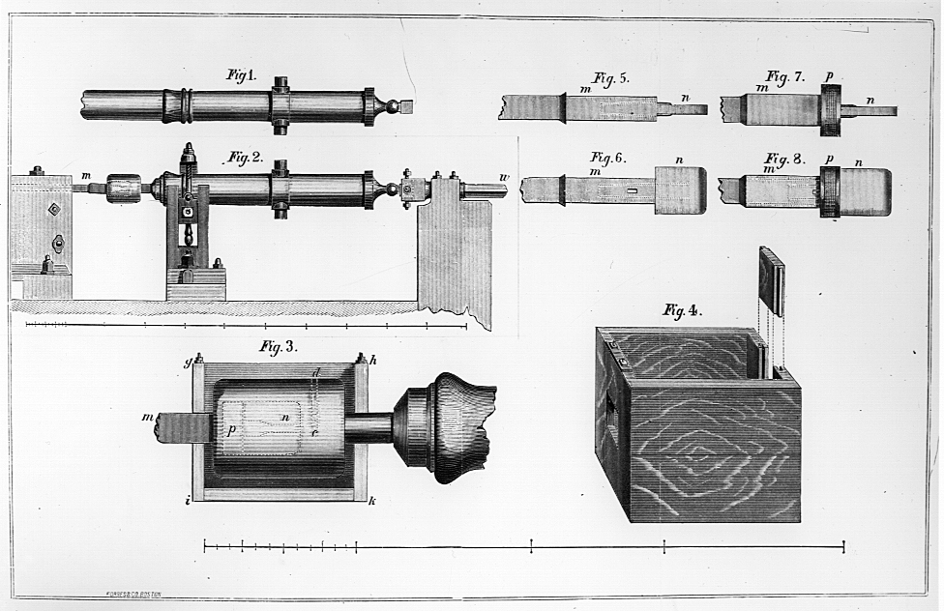

[Rumford contrived a way to conduct this experiment under water, so that the borer would not be in contact with air.]… 90 minutes after the machinery had been put in motion, the heat of the water in the box was 142° F. [At 2 hrs., the temperature was 178° F. At 140 min., it was 200° F; and at 150 min.,] it actually boiled! It would be difficult to describe the surprise and astonishment expressed in the countenances of the bystanders, on seeing so large a quantity of cold water heated and actually made to boil without any fire. This afforded me a degree of childish pleasure, which, were I ambitious of the reputation of a grave philosopher, I ought most certainly should hide…
By meditating on the results of all these experiments we are naturally brought to that great question…: What is heat? Is there any such thing as an igneous fluid? Is there anything that can with propriety be called caloric?
We have seen that a very considerable quantity of heat may be excited in the friction of two metallic surfaces and given off in a constant stream or flux, in all directions, without iteration or intermission, and without any signs of diminution or exhaustion. From whence came the heat which was continually given off in this manner, in the foregoing experiments? Was it furnished by the small particles of metal, detached from the larger solid masses, on their being rubbed together? This, as we have already seen [through experiments deleted here], could not possibly have been the case. Was it furnished by the air? This could not have been the case; for in [one] of the experiments, the machinery being kept immersed in water, the access of the air of the atmosphere was completely prevented.
Was it furnished by the water which surrounded the machinery? That this could not have been the case is evident: first, because this water was continually receiving heat from the machinery and could not, at the same time, be giving to, and receiving heat from, the same body; and secondly, because there was no chemical decomposition of any part of this water. Had any such decomposition taken place (which indeed could not reasonably have been expected), one of its component elastic fluids (most probably inflammable air) must, at the same time, have been set at liberty, and in making its escape into the atmosphere would have been detected; but though I frequently examined the water to see if any air bubbles rose up through it, and had even made preparations for catching them, in order to examine them, if any should appear, I could perceive none; nor was there any sign of decomposition of any kind whatever, or other chemical process, going on in the water.
…The source of the heat generated by friction, in these experiments, appeared evidently to be inexhaustible. …Anything which any insulated body, or system of bodies, can continue to furnish without limitation cannot possibly be a material substance. It is difficult, if not quite impossible, to form any distinct idea of anything, capable of being excited and communicated, in the manner that heat was excited and communicated in these, except it be MOTION.
nce to another.

Lectures on the Elements of Chemistry Delivered in the University of Edinburgh by the Late Joseph Black, M.D. From his manuscripts by John Robison (1803) [excerpted William Francis Magie, A Source Book in Physics (New York: McGraw-Hill, 1935)]
Translation by Robert Kerr (Edinburgh, 1790), pp. 3-7, 15, 26-30 [from Maurice Crosland, ed., The Science of Matter: a Historical Survey (Harmondsworth, UK: Penguin, 1971)] http://web.lemoyne.edu/~giunta/lavoisier2.html
http://www.chemteam.info/Chem-History/Rumford-1798.html

